Project Report
CS 6314. 502
Team Lemon

Wenteng Zhao (wxz190003)
Xiaochen Jiang (xxj190000)
Linzi Qi(lxq190000)

Abstract
In this project, we design a web site with web services implemented by Service Oriented Architecture. The website allows users to manage their accounts, buy or sell stocks on real time with queue or on schedule, check stock histories. We define 3 parts for the project: the web application and 2 web services. Our website also implements 2 features: Client-Server Communication Encryption using SSL and Request/Response Compression. Though we met some problems like transferring array list, select multiple stocks, create schedule, etc. We overcome them eventually with our hard work.

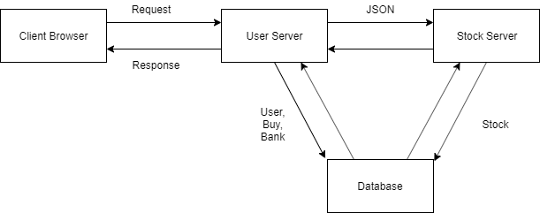
Architecture
This is the basic framework of our web architecture. All the information exchanged between servers are used by JSON.

Technologies
We use Tomcat as servlet container and use Maven to manage dependencies. We use JDBC to connect MYSQL database. Then, we transfer information with RESTFUL JERSEY through different servers. After that, we decide to transfer data format with JSON instead of XML through servers.
For the client side, we use JSP to create Front End,
We use servlet to manage the request from the Front End and other server, then send request back to some other servers to get the data.
In order to enable SSL, we use keytool to generate certification.
We compress our data as gzip.
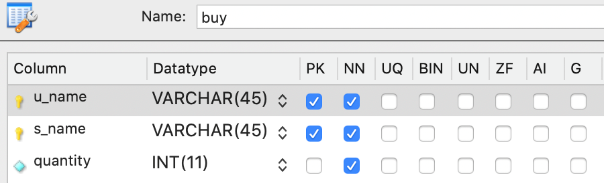
We use OAuth to achieve the authentication between each server.
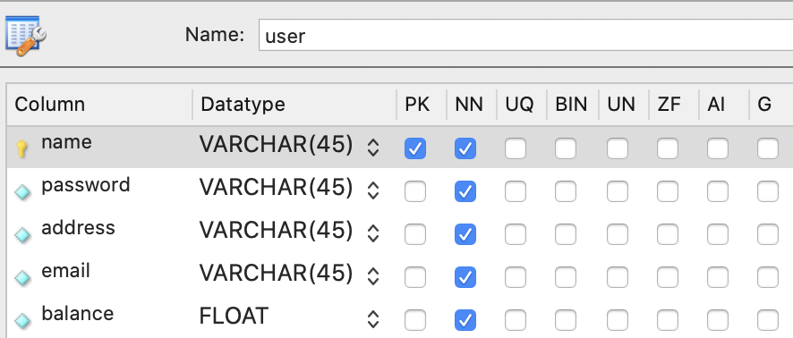
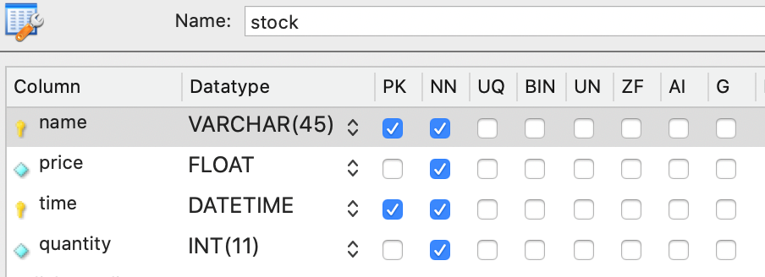
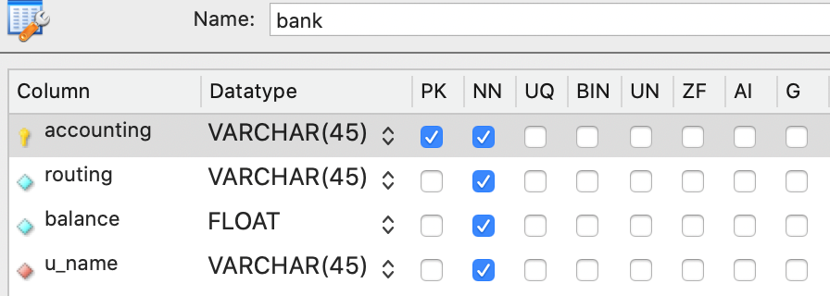
We use MYSQL database to store and update data. In the database, there are 4 tables for users to use: user, buy, bank, and stock. For the stock table, all the data are generated from a procedure called “Load5Year”. This procedure returns the data with random price and quantity for 5 years until now. To achieve the stock update through the increasing of time, there are 100 events for stock to auto update on every 30 seconds to insert a new piece of data with random price and quantity to the stock table. There is also an event with random name assigned by server, can create the schedule with specific time. Finally, there are many select function in MYSQL to trace back the history of stock information based on different time range.
Functionality
At the start of our website, there is a login page. There are 3 functionalities. If users do not create any accounts, there is a register button for them to enter the registration page and create a new account with information about their username, password, physical address, and e-mail address. Moreover, there is a chance for users who forget their password to get back them by providing their e-mail address. 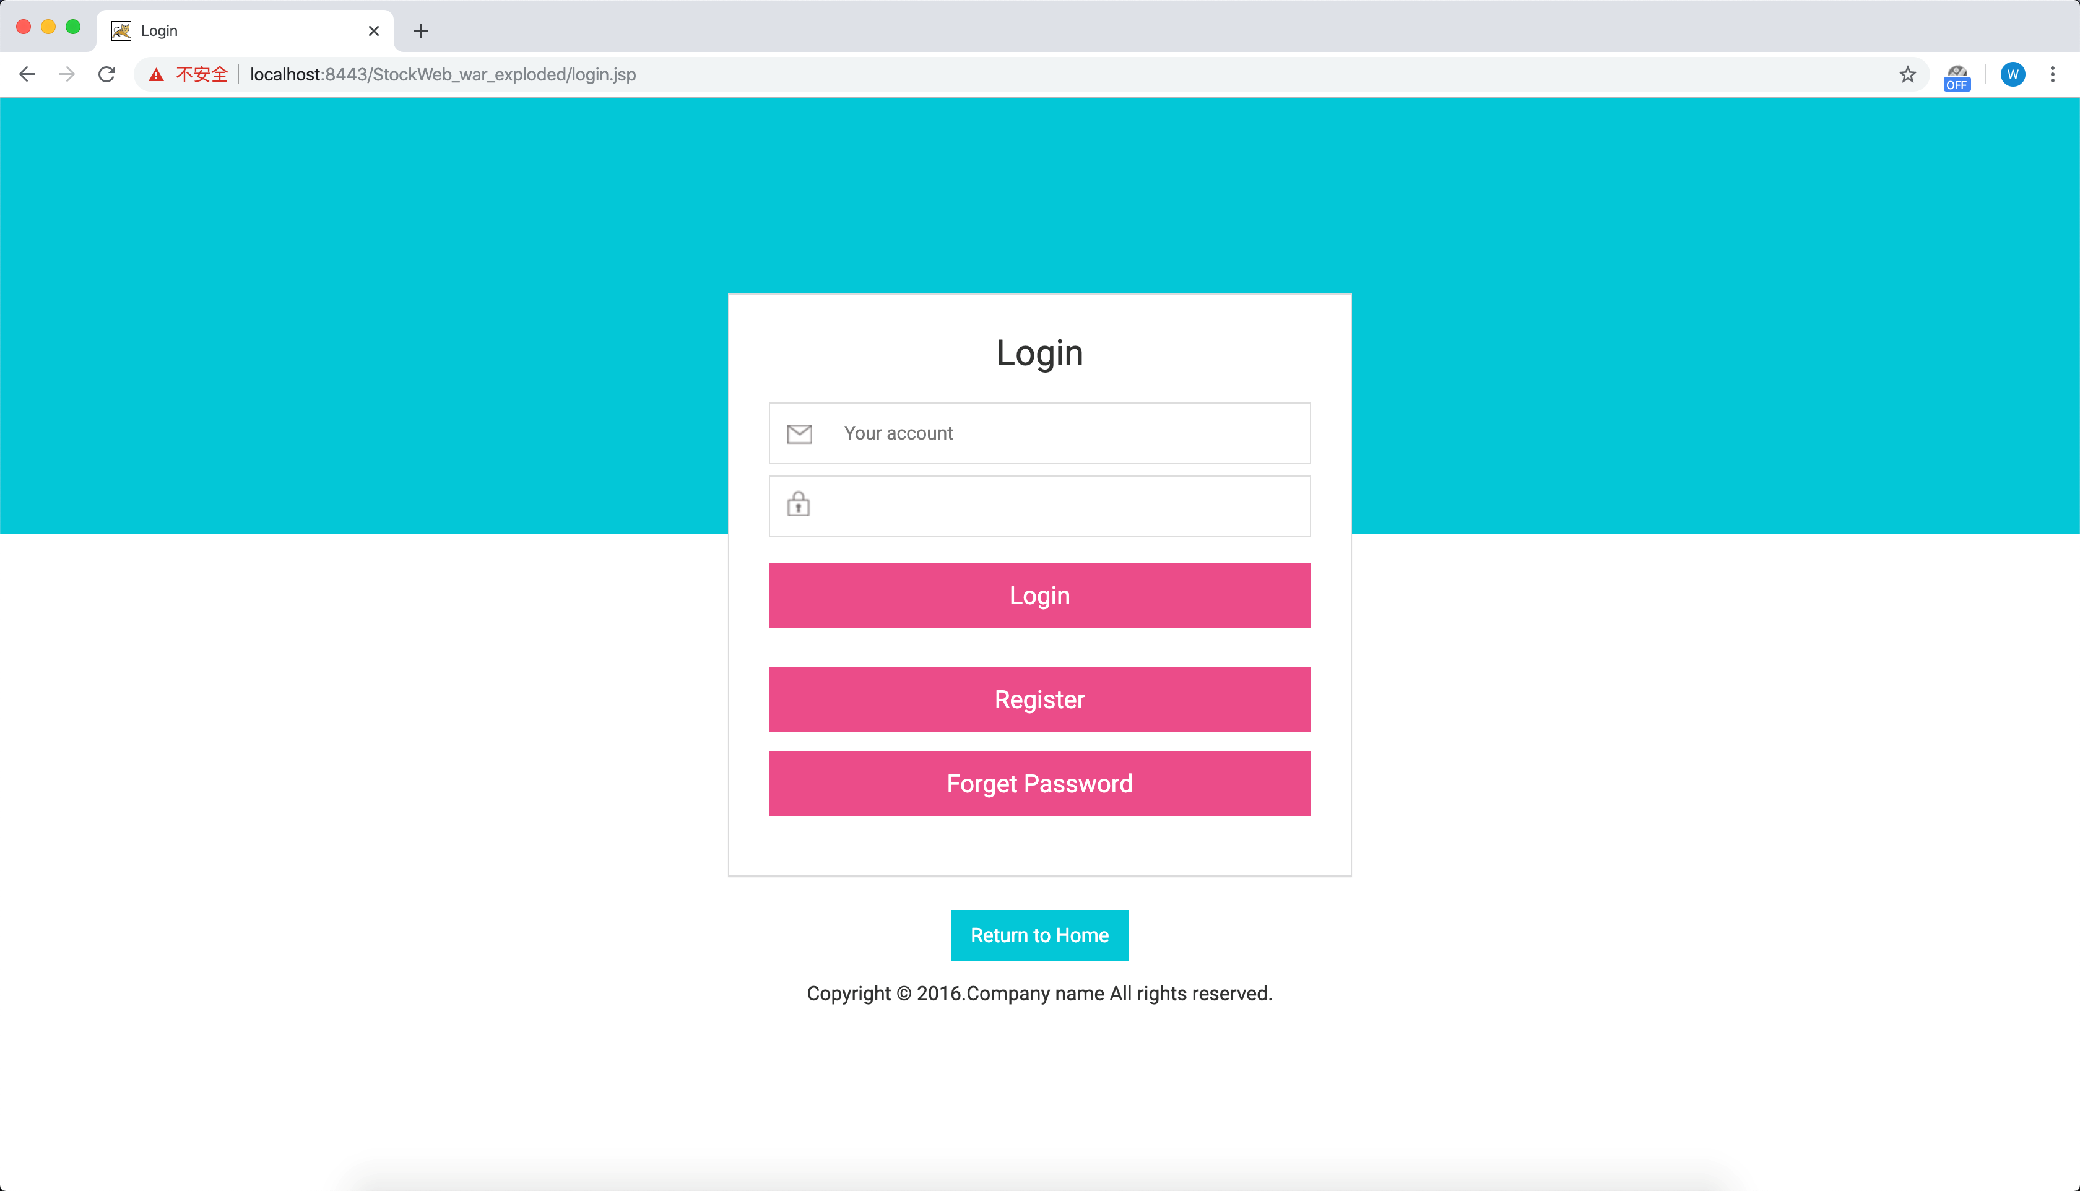
When users log into the webpage, there are 6 parts for users to explore and navigate: home, profile, bank, stock, history, and a bar for users to log out. The home page is a basic clean page where users first log in.
In the profile page, users are allowed to edit and save their personal information like their home address, e-mail, or phone number etc.
The bank page is a webpage where users can add their bank accounts include routing numbers and account numbers. Furthermore, users have the ability to add or delete different bank accounts, transfer and request money through these accounts or balance.
When user go to the stock webpage, they can buy the stocks based on their interests. It is convenient that we provide the current price and quantity of 100 types of stocks for users to navigate and buy. At the beginning of the webpage, there is a navigation bar for users to type in and find the information of their interested stock name. Also, users can click the header of each columns names to change the stock between ascending or descending order. All the information of stocks is updated 30 seconds and users can check it by refreshing the page. Besides information in the table, users can click “view details” to go a further step. After clicking the “view detail”, users go in the page where they can get the knowledge of stock price histories include the time arrange from: past 5 years, year to date, past week, current week, and last business day. Users have the choices to decide on whether buy the stocks now or schedule the wait time based on seconds. If the user does not have enough money in the balance for buying the stock based on the quantity which is the amount they input before, the page will give a warning of “buy failed”. Otherwise the page will give a sign “buy success”. 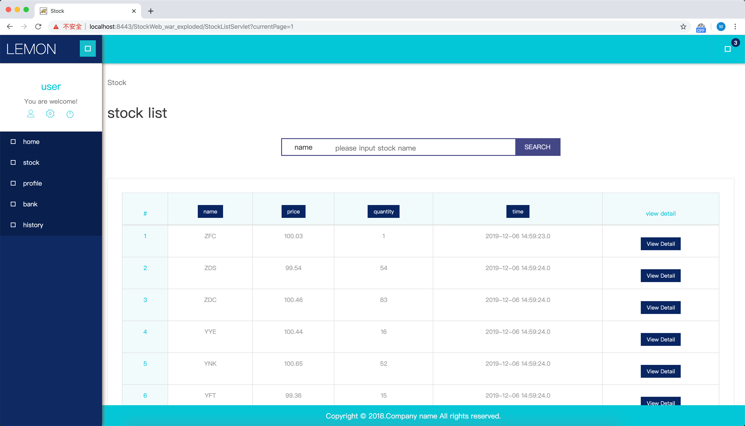
In the page of history, users will find their stocks which were bought before. The table of history also provides the function to order to the stock like above. Furthermore, users can click the checkboxes to select more the one stock to sell. In the next page after clicking the sell button, users can sell the stocks in a real time price or schedule the selling like the functionality of buying above.
Both buying and selling are implemented by queue in the database. In other words, when users finish buying or selling, the pieces of information are not added into the history page immediately. There is a 30s delay on every process due to the queue for the arrangement. Users have to wait until their requests being completed. That is how we achieve the Asynchronous Service. Additionally, our webpage is only available for user to buy and sell stock between 8 am to 5 pm weekdays. Other time our webpage does not provide the above services.
There is a chance that users may type the unavailable page. As a result, it will direct to a nice programed 404 page.

Web Services
The User server can offer the information about bank add, delete, transferring and retrieving. Moreover, it can check the user’s validation. It also contains the stocks that user bought in the past. There is another service that allows users to edit and change the information of their personal information.
The Stock server contains the functions to buy and sell stocks. Furthermore, it can show the stock information and detail by given 5 type of time range.
As said before, we use OAuth to achieve the authentication between each server. For example, after the user log in the webpage and website sending request to the user server, there is a JSON web token transferring back from user server to website. As a result, on every time this user sending request to the server, its token will be checked instead of user’ name and password.

Problems
Through the entire programming, we encountered some troubles and difficulties.
First, we met the problem that how to transfer the data of array list between different servers. We found out that it could be transformed as JSON and transferred it. The receiver received it and then deserialized it to array list before sent it back.
Second, we have the difficulty of selecting multiple stocks to buy and sell. We figured out that the checkbox was a good method for the front end to send an array list to back end.
Third, we stuck on the problem of schedule. We look through the internet and found that we could achieve it by creating an event in the database.
That were all the problems we met and how we overcomed.

